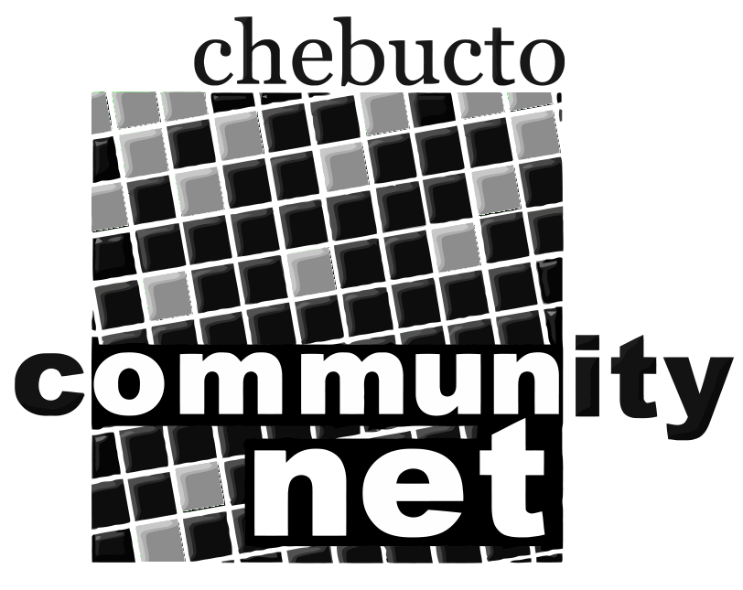 | Chebucto Community Net  Annual General Meeting  April 14, 2016
Technical Report
Dear Friends,
First of all, please accept my apologies for not having completed a proper Technical Report in time, and for not presenting it in person at the Chebucto Community Net's AGM this year. In truth I have been absent from CCN and from the Board of Directors for much of this past year.
But CCN has continued to move forward.
The Manors Project, which brings high-speed wireless Internet access to low-income public housing, continues on despite a mountain of paperwork and red tape necessary for mounting wireless equipment on the roof of Dalhousie University's Tupper Building.
The CCN Makeover Project, lead by Corrie Watt, continues its efforts to rejuvenate the servers, and services offered by CCN to its members.
On a personal note: I am resigning from the post of Technical Director at CCN, and from the CCN Board of Directors. Unfortunately I am no longer capable of meeting the requirements needed to fulfill this role. I would like to thank all members of the Board of Directors for their patience and understanding over the past year, and I commend them on their own dedication to CCN.

John Thibodeau
Technical Director
Chebucto Community Net

