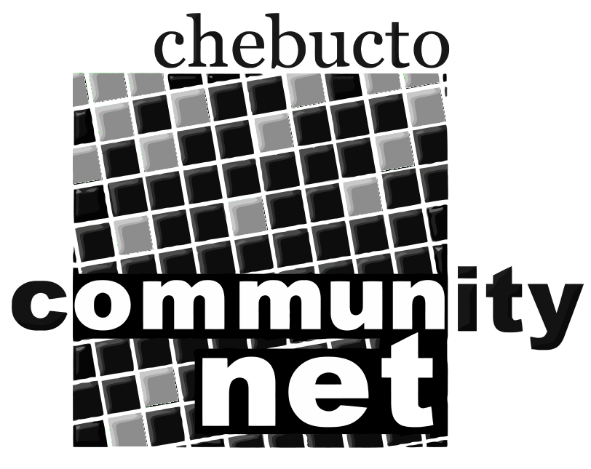 | Chebucto Community Net  Annual General Meeting  April 14, 2016
Policy Committee Report
The role of the Policy Committee is two-fold:
- to address policy development and implementation issues; and
- to address complaints or abuses about and by CCN members.
2015 was a lot of business as usual for the Policy Committee.
Unauthorized sharing of Chebucto Wireless login credentials has been the main issue facing the Chebucto Community Net with several warnings given and several devices permanently banned from the network. So far 5 of 103 Chebucto Wireless Manors accounts have needed to be warned about login sharing. In one of the cases the credentials were stolen when a neighbor had worked on the member's computer.
While sharing of login credentials is only done by a minority of users, detection of abuse is manual, not automatic. We still have not developed any policies regarding limiting simultaneous user logins; it is not uncommon a user might have a phone, a tablet and a computer online at the same time and some users have had as many as six devices online at once. There is a pattern of older relatives inheriting cast-off devices from the younger and many of these connect automatically in the background to the network.
We have seen a lot of torrenting on the highspeed connection with one user notably downloading some 360 Gb of material on a single day, or 1.4 times the Eastlink premium services monthly download limit. In 2015 we have received no copyright notice complaints against any Chebucto users.

Criminal abuse of Chebucto Community Net continues with network based attacks of various kinds and severity, usually launched from China and Eastern Europe. We had to suspend the long-time Guest login to the Chebucto text interface because criminals had found a way to exploit it to send out junkmail.
Phishing attacks where criminals try to trick users into either mailing their passwords to the criminals or direct the users to a website under the control of the criminals continued in 2015 but only one user fell for the scam. Their account was used to send out thousands of spams even though the intrusion was caught within four hours. Unfortunately these types of scam email can be difficult to filter but the criminals are having to put a lot of effort into a very marginal rate of return so the smarter crooks are already off to greener pastures like institutional ransomware.
That genuine Chebucto Community Net websites use Extended Validation SSL security certificates which spell out our name and turn the web browser address bar green in color gives our users extra protection against such crooks no matter what they say since they cannot fake this. It's very expensive but our users are worth it.
As in previous years we are looking for people interested in serving on the Policy Committee. Interested parties can submit their names to office@chebucto.ns.ca.

Andrew D. Wright
Chair, Policy Committee
Chebucto Community Net Society

