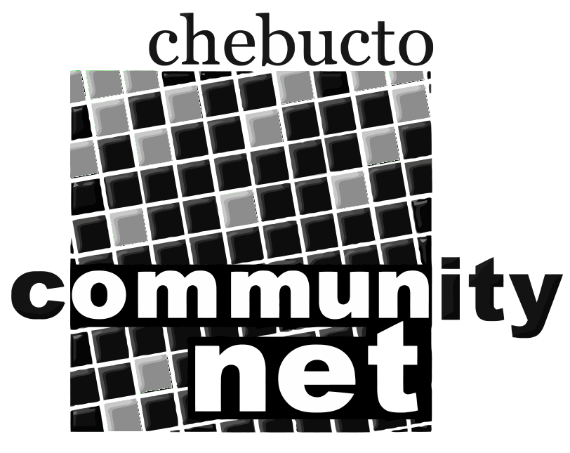 | Chebucto Community Net  Annual General Meeting  April 22, 2015
Treasurer's Report
In last year's report I mentioned expectations of grants to enable us to install wifi at more Manors in HRM. I am pleased to confirm that these came to fruition thanks largely to the fact that Andrew has been a tireless campaigner in IT circles and also a prolific user of social media to "spread the word". We received three grants totalling $70,000 and are in the process of installing wifi at three more Manors. Details are in the other reports you are receiving today.
In consequence our income this year has been $121,000 compared with last
year's $62,000. We started the year with cash balances of $27,426 and ended with $67,633. Of this latter $40,000 of the grant monies were still to be spent on completing the Manors installations. So we just about scraped through.
Again this is due almost entirely to Andrew's doing a full time job on half salary and Johnathan's putting in countless hours on a volunteer basis. Dave Johnston of Fresh Developments has also volunteered a tremendous amount of time and expertise installing at the Manors. We are upgrading our equipment and systems with most of the work being done by members of the Board.
For the future we hope to attract more grants to install at more Manors, thereby gaining more members. It is membership fees that pay our regular bills, and we still have to have more members in order to become self-sustaining. At this time our best prospect of increasing memberships is from the Manors.
Alan Turner
Treasurer
Chebucto Community Net Society

