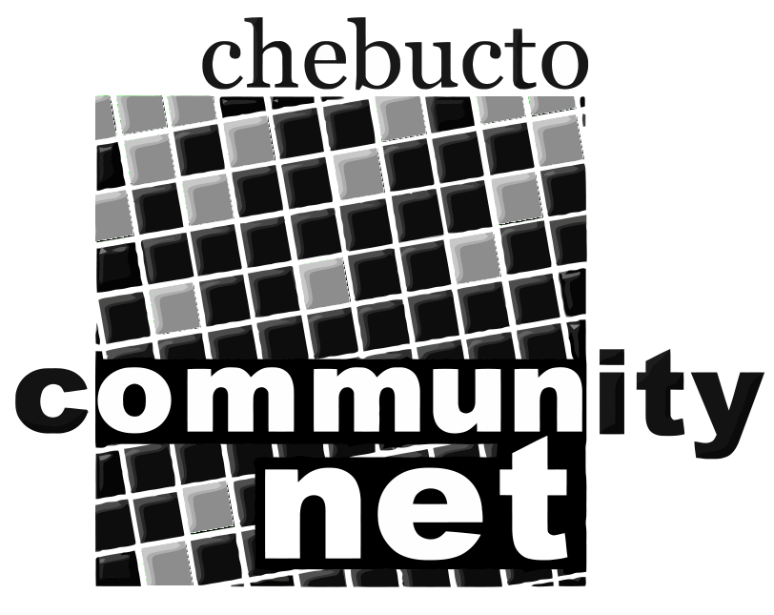 | Chebucto Community Net  Annual General Meeting  April 22, 2015
Report from the Chair of the
Board of Directors
It was a great feeling to open last year's Annual General Meeting by telling you that our Manors Project, bringing wireless Internet connections to Joseph Howe and HP MacKeen Manors was underway. It's an even greater one to tell you that that the next stage, bringing the same services to three more Manors in 2015 is well underway and that somebody else is paying for it!

We need to acknowledge the generous contributions of the donors who are making this happen: for Gordon B Isnor Manor, ACORN-NS, the Atlantic Canada
Organization of Research Networks, foots the bill; for Ahern and Sunrise Manors, CIRA--the Canadian Internet Registration Authority, signs the cheques. Both organizations are obviously making a great contribution to the lives of residents of the Manors and there may be more to come. Currently an application is before CIRA that, if accepted, will enable us to wire three more public housing complexes: Alderney and Eastwood Manors as well as Nantucket Place, extending our reach to the Dartmouth side of HRM.

In addition to their financial contributions, however, these well regarded and well connected organizations have also given Chebucto something we've struggled for over a great deal of time: visibility. Political leaders who had no idea who we are now get the idea. Media people, looking for comment or opinion on Internet issues now look to Chebucto or more specifically our office manager, Andrew Wright, as a go-to source of up to date information.

Last spring, Peter Menzies, the Vice-Chair of the CRTC, the Canadian Radio, Television and Telecommunications Commission, on a tour of the Atlantic Region, contacted us requesting a meeting. Several members of the Board, along with Andrew, met with him in May. Mr. Menzies told us of CRTC's plans and we told him about ourselves and our objectives about which he knew very little. We found common ground in discussing the possibilities of the CRTC's support for the concept of community Internet, as it does with community radio and he encouraged Chebucto to get involved in making submissions at CRTC hearings.

Apart from our donors, a number of people need to be thanked for making this what has been a very successful year for Chebucto.

The wiring of the Halifax Manors has been a hard, slogging job, often carried out under difficult circumstances: inside, working in hot, dusty and dirty conditions or outside on roofs in high winds and freezing cold. Our office manager has been front and centre in this work while also shouldering the responsibilities of keeping his office duties covered. Dave Johnston of Fresh Group Atlantic has been an unfailing source of hard work, advice on managing obstacles and on which would be the best equipment to buy. He's even occasionally cajoled his own family members and skilled colleagues to pitch in and help.

Back on the home front, many improvements have been made in our technical services by Johnathan Thibodeau and the Chebucto Tech Committee. Johnathan will have more to say about that in his report.

I want to extend my personal thanks to my fellow members of the Board of Directors. They've shown an admirable willingness to do what it takes to get the job done and have always, in my experience, acted from the starting point of what they believe to be in Chebucto's best interests. Thank all of you too for your belief in Chebucto and your continued support as well as for offering me the opportunity to serve.

Marilyn MacDonald
Chair
Board of Directors
Chebucto Community Net Society

