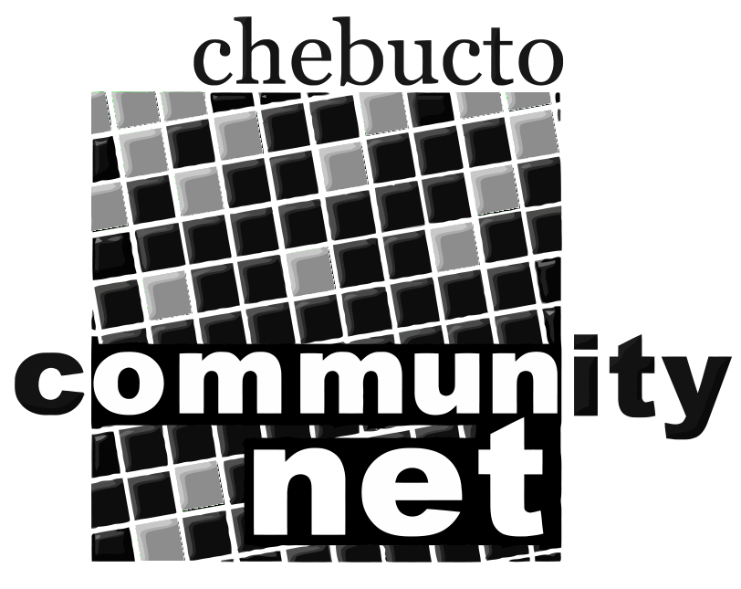 | Chebucto Community Net  Annual General Meeting  April 23, 2014
Treasurer's Report
For the past several years we have been watching our membership, and hence our income, decline. Our expenses exceeded our income and our reserves were steadily eaten away. This year, despite a steadily declining membership, was the second in a row that we ended up in positive territory. The excess of income over expenditures was not as great as that of the previous year - both income and expenditures were up - but for the first time we see positive aspects for the future.
Again we are deeply indebted to Andrew and Johnathan for maintaining the status quo. Andrew worked the whole year full time on half salary, and Johnathan took care of almost all our technical maintenance entirely on a volunteer basis. At the same time we have a lot to thank our Board members for. Financing for the installation of wifi in Joseph Howe and HP MacKeen Manors was done entirely in house, funded by donations mainly from Board members and an outstandingly generous one from our lone member of staff. We also have to thank those who volunteered the labour - and there was a lot of it - to complete the installation. Outside of this project a number of technically able board members worked in a committee that was instrumental in planning and executing much needed upgrades.
Brighter prospects for the future are caused by the fact that our achievement in providing WIFI to seniors' manors at one quarter or less than the charges of the two big local providers has gained some attention, and we have expectations of receiving grants from diverse sources that will enable us to install at more Manors.
We survive on our memberships and donations. If we can increase both of these our chances for survival are that much greater, maybe a second twenty years!
Alan Turner
Treasurer
Chebucto Community Net Society

