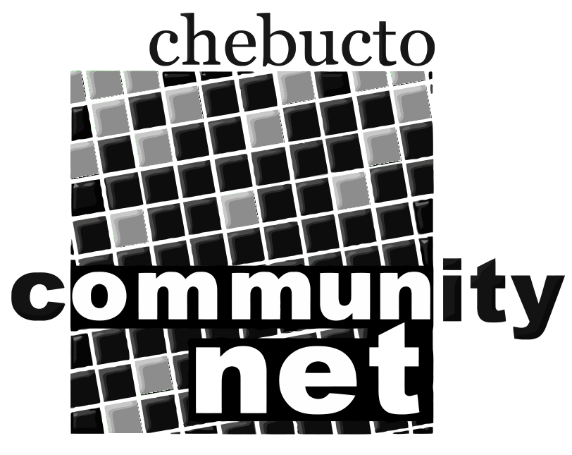 | Chebucto Community Net  Annual General Meeting  April 23, 2014
Policy Committee Report
The role of the Policy Committee is two-fold:
- to address policy development and implementation issues; and
- to address complaints or abuses about and by CCN members.
2013 was a quiet year for the Policy Committee.
A single user had their password compromised. Spammers immediately sent out thousands of junk emails from the hijacked Chebucto email account. We caught the abuse within a short time.
There were three cases of user computers on our network becoming compromised and trying to infect others. In all three cases the infected computers were removed from our network and in two of the cases the users were notified and able to fix or replace the infected computers. The third case was an unidentified computer on the Chebucto Wireless network that was barred from connecting again.
We cannot stress enough the need for only using updated Operating Systems and programs, and making sure they are kept safe with good security software including anti-virus and anti-malware protection.
As in previous years we are looking for people interested in serving on the Policy Committee. Interested parties can submit their names to office@chebucto.ns.ca.
Andrew D. Wright
Chair, Policy Committee
Chebucto Community Net Society

