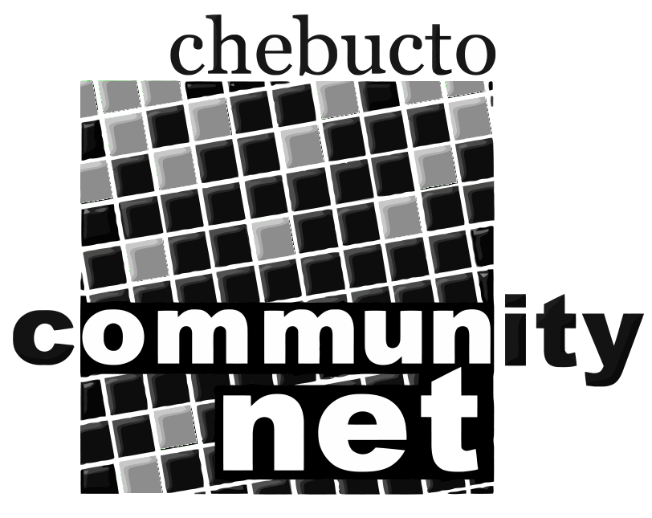 | Chebucto Community Net  Annual General Meeting  April 17, 2013
Report from the Chair of the
Board of Directors
It's been said in recent years at Chebucto that the Chair's report to the AGM should simply consist of two words: "We survived." Well, in 2012 we did a bit better than that.

We lived well within our means, finishing the year with a balance of $10,873 income over expenses. *I should point out, however, that we would not have achieved this without continuing to pay our office manager a part-time salary for what is really a more than full-time job.* Our Credit Union balance is good, standing at just over $40,000, including both operating and reserve accounts.

We have also branched out into new areas. In 2012 a firm called Fresh Group Atlantic contacted us and came to meet with the Board last October. They wanted to bring high speed wireless access to the Agricola Street area and they were requesting that Chebucto become the ISP for this project. After considerable thought and discussion, the Board offered them a counter-proposal: for years we had been searching for some way to bring such a service to Joseph Howe Manor, a low-cost public housing development in Halifax. We proposed to pay them to install the equipment there and we would run the service as a pilot project.

We subsequently approached the city to investigate the possibility of a grant for the project. Somewhat to our surprise, we got a very quick and very positive response. Unfortunately--and very much at the last minute--things fell apart and we were faced with a decision: abandon the project, or go ahead on our own. At its March, 2013 meeting, the Board voted to go ahead and what was now the Manors Project, including H.P. MacKeen and well as Joseph Howe Manors, was officially on its way.

Earlier in 2012 we had been informed by our longtime host, the Dalhousie Mathematics Department, that extensive renovations would be carried out in our office, room 125, and that we would be required to move out, to temporary quarters in the basement of the Chase Building. For staff and a number of Board members, last summer's memories include a massive amount of labeling, packing up and transporting all of the contents of the office (you'll perhaps recall that our decor leaned toward the overstuffed side) to a storage facility. But we were all looking forward to our newly refurbished digs. Sadly, we never got to move in. The math department informed us that it was taking back Room 125 for its own use and that basement room 006 was now our new home.

We are still undoing the tangles of that unfortunate experience. Everything in storage had to be moved, some to the Chase Building, most to less expensive private storage, but at least we still have a home and, to be sure, the price is right.

On a happier note, I would be remiss if I didn't point to the success of Chebucto's presence on the social network, Twitter. Of all the efforts we have made to increase public awareness of Chebucto, it has been far and away the most productive. Our number of followers has grown steadily and by a metric that Twitter itself uses, we get "re-tweeted" a lot, that is, our followers tend to re-send our little messages to their own followers. Chebucto on Twitter is entirely the work of Andrew D, Wright and we applaud loudly as it continues to bring Chebucto to the world.

In closing, I would like to extend my truly heartfelt thanks to Andrew and to the members of the Board of Directors for their exceptionally hard work and commitment over the past year. We have a lot of work ahead of us and we'll need a little luck as well as good management. But I sincerely believe that we are better positioned to achieve success than we have been for some time.

Marilyn MacDonald
Chair
Board of Directors
Chebucto Community Net Society

