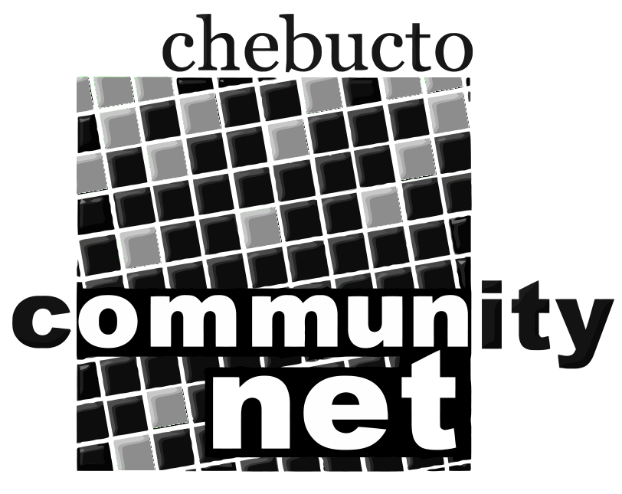 | Chebucto Community Net  Annual General Meeting  April 25, 2012
Agenda

1. Presentation by Andrew Wright

2. Call to order

3. Minutes of the 2011 Annual General Meeting

4. Report from the Chair

5. Treasurer's Report

6. Report from Policy Committee

7. Technical Report

8. Election of Directors

9. Appointment of Auditor

10. Other business

11. Adjournment

Only members in good standing are eligible to vote on the motions presented or be nominated for office. Proxy voting is not allowed.

