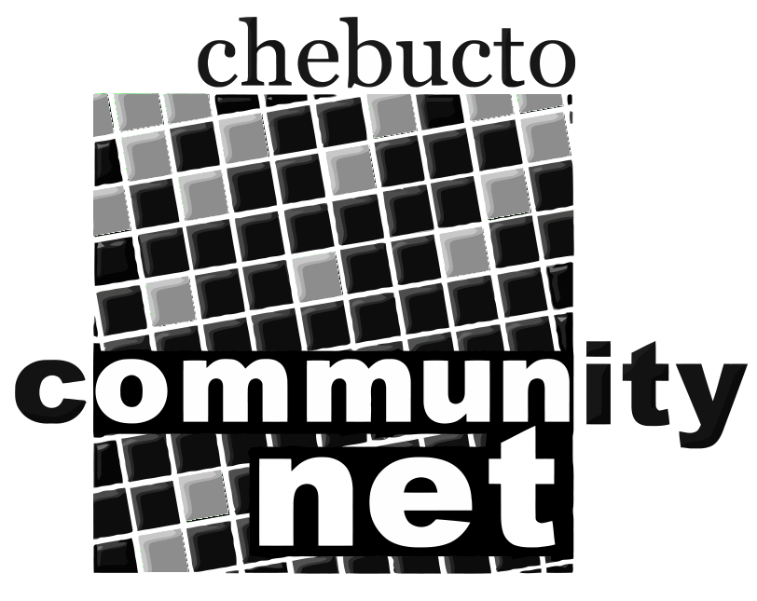 | Chebucto Community Net  Annual General Meeting  April 27, 2011
Agenda

1. Presentation by Dan Robichaud from Halifax Regional Community
Access Program.

2. Call to order

3. Minutes of the 2010 Annual General Meeting

4. Report from the Chair

5. Treasurer's Report

6. Report from Policy Committee

7. Technical Report

8. Election of Directors

9. Appointment of Auditor

10. Other business

11. Adjournment

Only members in good standing are eligible to vote on the motions presented or be nominated for office. Proxy voting is not allowed.

