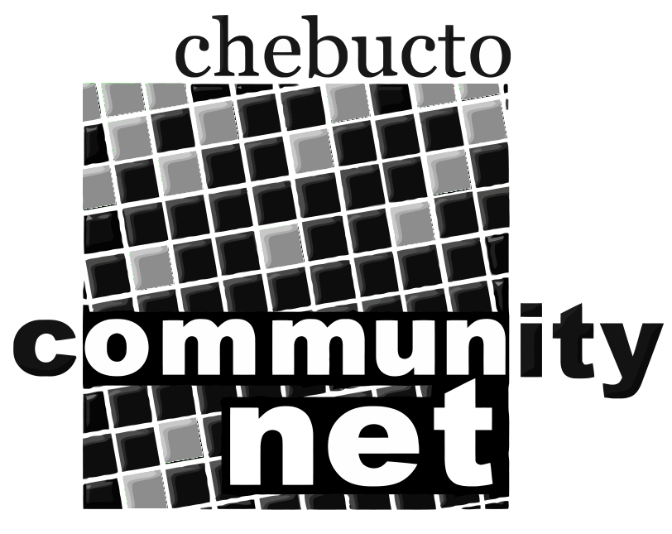 | Chebucto Community Net  Annual General Meeting  April 29, 2010
Budget 2010
INCOME | EXPENSE
Enrollment 61000  Donations 6000  C@P 2700  -----  69700  ----- | Payroll 32000  Eastlink 20000  Hardware 4500  Office 900  Accounting 1300  Insurance 2400  Phone 1000  Credit card 1500  ACORN 1130  Dalhousie 4000  Miscellaneous 600  -----  69330  -----
 | Surplus 370

